**Effects of biological and environmental covariates on the size-weigh**

**t relationships of Eastern and Northern Bering Sea crab stocks**

Jonathan I. Richar, W. Christopher Long

**Abstract**

The modeled size-weight relationship is a critical component in expanding fishery independent survey-derived data to create population estimates for Bering Sea crab stocks. Current procedures assume this relationship to be constant across a range of crab physiological parameters, environmental conditions and geographic ranges for the purpose of creating biomass estimates. Effects of shell condition, environmental temperature, and region on the size-weight relationships of red king crab, blue king crab, snow crab and Tanner crab were assessed using a combination of least squares and maximum likelihood methodologies. For female Tanner and snow crab, effects of clutch size were also evaluated. Population biomass estimates were derived using calculated model parameters, and then compared to estimates calculated using the current fixed parameters. Shell condition, temperature, male maturity status and clutch size influenced the size-weight relationship, with species-dependent differences in covariates and degree of effect(s). Large differences between eastern and northern Bering Sea stocks were also observed across species. Results for models considering clutch size were mixed, and species/procedure dependent. Relative to estimates calculated with the current standard models for these stocks, male biomass estimates were modestly larger when applying shell-condition/matrurity based models, particularly for Tanner crab, with some interannual variability. These results suggest that it may be appropriate to reconsider and update current biomass estimation procedures used in stock assessment for at least certain stocks.

**Introduction**

Red king crab, *Paralithodes camtschaticus*, blue king crab, *Lithodes platypus*, Tanner crab *Chionoecetes bairdi*, and snow crab *Chionoecetes opilio* are the basis of economically valuable fisheries in the eastern Bering Sea (EBS). In the northern Bering Sea (NBS), interest in snow and blue king crab is likely to increase with improved access due to reduced sea ice related to anthropogenic climate change, and Norton Sound red king crab already support locally important commercial and subsistence fisheries. An important component of both effective fishery management, and understanding population trends for these stocks is the calculation of biomass estimates based on size frequencies, through the use of size-weight models based on a subset of the survey catch. The current model implementations used to generate estimates for these stocks assume a constant relationship for each sex, and for females, maturity status, across a range of environmental conditions and crab ages post molt, (Zacher et. al 2020).

Individual crab weights may however be influenced by factors beyond the size, sex, and maturity status of the given individual. Time elapsed since the last molt is likely to be one of the most important of these factors, due to increased mineralization of the carapace and increased growth of internal tissue with time. Shell condition is used as a qualitative indicator of time elapsed; for the research presented here, categories used were shell condition 2(SC2)/new shell (NS), shell condition 3(SC3)/old shell (OS) and shell condition 4 (SC4)/ very old shell (VOS). Shell condition 5 (SC5)/ grave yard crab were not analyzed. New shell crab are expected to have molted recently, typically within the last few months, OS crab are expected to have molted the prior year, and VOS crab are expected to have molted more than one year previously. For a full description of shell conditions and diagnostic criteria please see Jadamec (1999).

The size-weight relationship may also be influenced by relative meat fill (i.e. the amount of soft tissue) within the crab’s carapace, which is itself influenced by both the time elapsed since last molt, and the crab’s condition. Because OS/VOS crab will have had more time for tissues to develop since their last molt, it is likely that they will have greater meat fill than their NS counterparts. Importantly, temperature can influence both individual condition and time elapsed since last molt by altering molt timing and molt intervals (Chilton et al. 2010; Stevens 1990), and thermally stressing the given crab (Azra et al. 2020). Consequently, a crab’s environment may also influence the size-weight relationship, particularly when the crab is sampled under rigid, standardized procedures, such that crab in a given area will be sampled at the same time every year.

A crab’s size-weight relationship is likely to be influenced, albeit to a lesser degree, by mineralization and condition of the carapace. This is related to the time elapsed post-molt; increasing with time to a certain point, then declining as the crab approaches the graveyard stage and senescence. Old shell crab are likely to have the most mineralized and densest carapace structure, while SC2, SC4, and SC5 crab will have comparatively less mineralized, and less dense carapaces; the first due to limited time to mineralize post-molt, the latter two due to age-related deterioration and shell disease. Red king crab, for example, take about 74 days to reach 90% of their asymptotic hardness levels (Stevens, 2009) and SC4/5 snow and Tanner crabs have noticeably pliable shells compared to SC2/3 crabs (personal observation) indicating reduced mineralization.

Crab which have not molted recently often have communities of encrusting organisms growing on their carapace, including hydroids, barnacles and tunicates. Because epibionts are an important factor in distinguishing between NS and OS crab, OS crab, which usually have a much more epibiont growth, are likely to be more affected than NS crab, which typically have little or none (Jadamec 1999). Notably, because affected crab weigh more than comparable individuals with clean carapaces, due to the additional mass of these organisms, efforts are made to either exclude such crab from being weighed altogether or at a minimum, remove these epibionts from the carapace prior to weighing.

Finally, a consideration unique to mature female crabs is the effect of the egg clutch on the measured weight of the given female crab. Current survey procedures treat the weight of the egg mass as a component of the female crab’s weight, thus survey personnel do not remove egg clutches prior to weighing a mature female crab. Because egg clutches can attain relatively large sizes, it is reasonable to expect that they will be a significant component of the size-weight relationship, and furthermore, that larger egg clutches will result in greater weights for the given female, relative to a same-sized crab with a smaller clutch.

In the work presented here, size-weight relationships are modeled based on shell condition (SC) for male Bristol Bay red king crab (BBRKC), St. Matthew blue king crab (SMBKC), and both male and female EBS Tanner crab (EBS TC) and snow crab (EBS SNC). These models are then used to assess the degree to which the use of SC specific size-weight models alters population biomass estimates that are used in the assessment of these stocks. For female EBS TC and EBS SNC, effects of clutch size (CS) on the size-weight relationship within shell condition categories were also considered. In addition, the effects of temperature on the size-weight relationship in new shell male and female BBRKC, EBS SNC and EBS TC is investigated. Finally, size-weight models are fit for Norton Sound red king crab (NRTN RKC), Northern Bering Sea blue king crab (NBS BKC) and Northern Bering Sea snow crab (NBS SNC) to evaluate regional differences between these stocks and their EBS counterparts.

**Methods**

For the greater EBS region, crab were sampled during summer bottom trawl surveys conducted by the Alaska Fisheries Science Center during June-August in the years 2000-2019, though there were inconsistencies in sampling effort, and weights were not taken during all years for every species in this series (Tables 1, 2, 3). For the NBS, crab were sampled in August-September during the years 2010, 2017-2019, and 2021-2022.

For temperature-effect models, station near bottom temperature (NBT) measurements were weighted by station catch-per-unit-effort (C+PUE) separately for male and female crab as

[1] ,

Where *T* is the weighted temperature estimate for year *y* for crab group *c*, NBT is the temperature recorded at station *i* in year *y*, and CPUE is the catch-per-unit-effort, calculated as per Zacher et al. (2023) for crab group *c* at station *i* in year *y.*

Individual length/width is currently measured to the nearest 0.1 mm using digital calipers while prior to 2015 measurements were taken using Vernier calipers. In addition, prior to 2006, measurements were taken to the nearest 1 mm only. Crab weights were measured to the nearest 2 g via a digital scale. Shell condition, which is used as an index for time elapsed since the most recent molt, and is based on carapace wear and epibiont accumulation, was classified as per (Jadamec 1999). Crabs were only measured if they had no missing or regenerating limbs, were not cracked or crushed, and had minimal epibiont fouling. Typically, 5-15 crabs per sex, per species, were haphazardly selected for measuring from each haul where encountered; however, for BKC, because of their very limited range, all crabs that met the physical criteria were typically measured. For analysis purposes, SC2 crab were categorized as NS, while SC3 and SC4 crab were grouped into an OS category; small sample sizes prevented consideration of SC4 crab separately. Poor crab condition (i.e., missing limbs), and heavy epibiont growth typical of the SC5 state, and an overall low frequency of these crabs lead to even smaller sample sizes for this category; as a result, sample size was inadequate and this shell condition category was not included. Small sample sizes also prevented robust calculation of size-weight models for OS NBS SNC thus size-weight models for this stock incorporated all shell conditions, with a focus on evaluating differences relative to EBS crab. Sample sizes by species, sex, SC, and year are given in Tables (1, 2).

In clutch-bearing mature female crab, the egg mass is likely to influence the size-weight relationship, particularly as a function of its CS, a measure of the physical size of the egg mass. Currently survey personnel score CS on a range from 0 (no eggs) to 6 (full clutch, with eggs protruding) as per Jadamec (1999). For female models considering the effect of clutch-size, only EBS TC and EBS SNC females were investigated, for clutch-sizes of ½, ¾, and full, as it was felt that classification protocols for these clutch sizes and species were least susceptible to error due to subjectivity (Jadamec 1999).

For analysis, as a first step, exploratory least sum squares (LSS) models were run; this facilitated comparisons with both with prior models (Chilton et al. 2010), through procedural consistency, and follow-on maximum likelihood (ML) models via use of the same base data. Maximum likelihood models were run using forward selection, beginning with a basic null model, and proceeding to a full model incorporating all relevant covariates, with interaction terms where deemed reasonable.

For modeling, the allometric size-weight relationship may be modeled as

[2]

where *W* is the measured weight in g, *L* is the corresponding carapace size measurement (length/width) in mm, and *a* and *b* are model estimated parameters. For LSS modeling this was linearized via log-transformation as

[3] ,

which permitted parameter estimation via linear modeling methodologies using the statistical software R (R Development Core Team 2019). The use of log10 maintained strict consistency with procedures used for the current standard size-weight model parameters (Zacher et al. 2023).

For the LSS-approach, separate models were fit for crab pooled by shell condition for males, and for females for crab pooled by both shell condition across clutch-size categories, and by clutch-size category within shell condition groups. Initial models were tested for outliers, using Cook’s Distance, and any such data points were removed prior to fitting the final size-weight models. To test for equality of the model size-weight relationships when compared between groups, the *aov()* function resident to the R package *stats* was used to model the log-transformed weights as functions of the log transformed widths, with either SC, or for females, clutch size, included as either an interactive (to test for similarity of slopes) or additive (to test for similarity of intercepts) term.

Because a final objective for this work was to develop size-weight models that can be used in stock assessment models, all available data were employed to ensure that models were representative of all size classes sampled. Old shell males are however more prevalent at larger size classes, leading to a mismatch in size ranges represented in the data, which may drive model differences between NS and OS groups. To address this, for BBRKC, EBS TC and EBS TC males, data were subset into two secondary data series; the first with a size cutoff corresponding to the size of the smallest observed OS males (BBRKC, >79 mm; EBS TC, >40 mm; EBS SNC, > 36 mm), and the second with a cutoff corresponding to the lower boundary for upper 3 quartiles of OS males (BBRKC, >132 mm; EBS TC, >106 mm; EBS SNC, > 76 mm). These data were exclusively used to test sensitivity of model relationships to size compositions, and derived parameters were not applied in further analyses (e.g. biomass estimation).

As a followup to the exploratory LSS modeling, ML modeling procedures were used to assess for environmental and interactive effects on the size-weight relationship. For these models the *a* and *b* parameters were each broken into a base-effect parameter, and separate parameters for each covariate effect included in the given model as;

[4] , and

[5] ,

where *x1*...*xi*are the specified covariates, and *xi* * *xj*is the related interaction term.

For male crab, shell condition, temperature and for *Chionoecetres spp.*, morphometric maturity status as defined by the methods of Richar and Foy (2022) were explored. For female crab, shell condition and temperature were used. Attempts to implement models employing clutch size as a parameter were unsuccessful. Model selection was achieved using the small sample size Akaike Information Criterion (AICc). For comparison between the EBS and NBS, null effect models were used.

Differences in weight-at size were calculated using the “best” ML models, and were approached from several angles due to the combination of factors influencing crab weight: For the warmest and coldest years, new shell and old shell model output were compared. Likewise, within the new shell and old shell groups, models estimated weights for the warmest and coldest years were compared.

To assess the effect of considering size-weight relationships including covariates on population estimates, SQL-based analysis codes presently employed to calculate area swept biomass estimates were amended to use the covariate-based size-weight model parameters in lieu of the standard model parameters. For these models, we only considered temperature and shell condition, as incorporating maturity status would require significant additional research focusing specifically on old shell crab to account for old shell immature crab, or “skip-molters”, which would have been beyond the scope of the work presented here. Individual crab weights were first calculated using the appropriate size-weight model with the new parameters, (Eq. 1) and converted to kilograms. For males, new shell models were applied to SC 1 and 2 crab, while OS models were applied to SC 0, 3, 4 and 5 crab.

Catch-per-unit-effort by weight was then calculated as

[6] ,

where CPUEWbji is the CPUE by weight in kilograms/nmi2 in size bin *b* at station *j* in year *i*, *Wb,j* is the total weight, in kg, of crab *N* in bin *b* in station *j*, *NWj* is the average net width in meters at station *j*, *Dj* is the distance fished, in km, at station *j* and *k* is a constant (0.29155335) converting km2 to nmi2. Stock biomass may then be calculated as

[7] ,

where, *CPUEWjis*is CPUE (weight) for size bin *b* at station *j*, in strata *s* and year *i*, *nsi*is the number of stations sampled in strata *s* in year *i*, and *Asi* is the area of strata *s* in year *i*. Finally, percent differences were calculated as

[8] ,

where *Bn* is the biomass estimate for stock *s* in year *i* calculated using the new parameters, and *Bo* is the corresponding estimate for stock *s* in year *i* calculated using the current parameter set. We did not attempt population estimates using size-weight models incorporating temperature data, while difficulties experienced separating effects of clutch-size, and shell condition in females meant that population biomass estimates were not attempted for females.

**Results**

Least squares model estimated parameters may be found in Tables (4, 5). ANCOVA results may be found in Tables (6, 7). Maximum likelihood model estimated parameters may be found in Tables (8, 9, 10).

Although model parameters differed between LSS and ML models (Tables 4, 5, 9, 10), likely due to inherent procedural differences, model findings did not. Consequently, for brevity we focus on the maximum likelihood model findings unless explicitly stated otherwise.

Plotted data points and fitted model regression lines may be examined in Figs (1, 2, 3, 4). New shell crabs weighed less than old shell crabs at all sizes (ANCOVA, Tables 6, 7, Figs 1, 2, 3, 4). Temperature related effects were seen across all crab stocks, and were most apparent in BBRKC and EBS TC (Figs 1, 2, 3, 4), with crab generally being heavier in warmer years. For male EBS TC and EBS SNC, maturity status was found to significantly affect the size weight relationship. For female models incorporating shell condition and clutch size, OS females and those with larger clutches were found to weigh more at a given size than NS and smaller CS females (Table 7). ANCOVA results suggest that in all LSS SC-effect model comparisons, excepting those for BBRKC SC, LSS model slopes were significantly different (Table 7). These findings suggest that the relationship between size and weight differs based on SC, temperature.

Limiting NS male data to the same size ranges as OS males affected LSS model parameters, but did not fundamentally alter the SC based size-weight relationships: in all cases models still indicate that OS males are heavier for a given size than are new shell males. Because of this, models developed using concatenated data were not adapted for further use in the calculation of biomass estimates. For BBRKC, models using the 79 mm cutoff (giving a NS size range matching the size range observed in baseline OS data) did not differ significantly from baseline models (Table 4). Increasing the cutoff to 132 mm for NS males changed the slope, but did not significantly alter the intercept relative to the NS baseline, while the same cutoff increased the difference between the NS and OS models, such that slopes significantly differed (Table 4). Use of minimum size cutoffs for the NS males did not notably alter conclusions for either *Chionoecetes spp.* when comparing between SC groups. Intercepts for NS models employing data delimited using either cutoff were statistically different from baseline model intercepts; slopes however only differed in EBS SNC models (Table 6).

Shell condition, maturity, clutch-size and temperature all affect the weight-at-size relationship (Figs 4, 5, 6, 7, 8, 9). Before proceeding, an important caveat when interpreting size-at-weight output is that due to crab biology, specifically molt intervals and for *Chionoecetes spp,* size at maturity and the associated terminal molt, OS crab only occur at or above certain sizes (RKC, 60 mm CL; BKC, 50 mm CL; CO/CB, 20 mm CW), thus model divergences below these cutoffs are biologically meaningless and are not depicted.

For BBRKC comparisons of weight-at-size between model groups gave results that were nearly constant across sizes and conformed with expectations (Fig.5a). Conversely, for male SMBKC distinct differences between weight-at-size estimates were observed based on the model comparison in question (Fig. 5b). EBS SNC most closely agreed with the standard estimates at larger sizes, while the reverse was true for EBS TC (Figure 6), with this being most pronounced for OS males (Figure 6). For male EBS TC comparisons by shell condition within temperature groups yielded a marked trend of old shell crab being heavier at larger sizes, with the difference increasing with size (Figs 6a, 6b). Differences were much less pronounced when temperatures were compared within shell condition groups, with trend lines being much flatter (Figs 6a, 6b). Lower magnitude differences were observed in EBS SNC, relative to EBS CB, with nearly identical trends between temperature by shell condition models, and shell condition by temperature models, suggesting a comparatively limited effect by temperature ( Figs 6c, 6d).

For female EBS TC, trends in divergences observed in weights calculated using shell condition/temperature and clutch-size-based LSS models were generally similar to those observed in male BBRKC, with OS, and full-clutch female models giving a larger weight than the baseline at smaller sizes, while the NS and half-full models gave a smaller weight, and all converging with the baseline at larger sizes. Interestingly, although ½ full and full-clutch NS models showed a marked difference in calculated weights at size (Figure 7c), the OS specific ½ full and full models demonstrated high similarity (Figure 7d). For female EBS SNC, OS, large-clutch models gave weight-at-size estimates most similar to the baseline, with deviations being greatest at smaller sizes, and smallest at the largest sizes (Figs 8a, 8b). As with EBS TC, ½ full and full OS models were much more similar than their new shell counterparts (Figs 8c, 8d).

Comparison of EBS and NBS null model results indicate that for NRTN RKC, the EBS null model will underestimate weight at size at smaller sizes, relative to an NBS-specific model, while the two will converge at larger sizes. For NBS BKC, however, the EBS model would overestimate at smaller sizes, and underestimate at larger sizes. Finally, for NBS SNC, the EBS-region models currently applied to this region will under estimate crab weights for these species at the smaller sizes most commonly encountered, while over estimating them at larger sizes more rarely encountered (Figs 9a, 9c). This was particularly true for NSRKC, where the BBRKC model underestimated OS male weights by up to ~15% within the size interval (>60 mm CL), in which such males are observed in this region. The reverse is the case for both NS and OS NBS BKC (Figure 9b).

Annual population biomass estimates calculated combining SC and temperature effects models exhibited a variable relationship relative to the standard model based estimates, with EBS TC models exhibiting the greatest divergence (Figure 10). On average however, absolute differences between the baseline and SC models were modest (Table 10).

**Discussion**

In the work presented here, it was demonstrated that SC, male maturity status, CS and environmental temperature affect the size-weight relationship in crab sampled from the eastern Bering Sea continental shelf. Furthermore, it was shown that current models fitting a single size-weight relationship to all crab of a stock, regardless of SC, are likely to be biasing population biomass estimates, with the magnitude of this bias varying by SC with crab size class, and sampling year.

As previously observed, it is likely that at least a portion of the weight increase observed in OS crab relative to NS individuals of the same size is the result of epibiont growth on their carapaces. It is however standard protocol to either select clean crab, or if this is not possible remove any such organisms prior to weighing, otherwise personnel will not weigh the crab in question unless remaining epibionts are considered unlikely to significantly increase the measurement (pers. observation). Consequently, the increase in weight is likely primarily due to endogenous factors—higher meat fill within the carapace, as crab will have had a year or more to fill out since their last molt, and heavier, denser carapaces due to increased calcification (Somerton and MacIntosh 1983), or for male *Chionoecetes spp*, the morphometric changes associated with attaining maturity, which OS crab are likely to have done.

Under the current standard approach of fitting a single size-weight model, our findings suggest that weights for OS crab are biased low, most notably for mature male OS Tanner crab, while weights for NS crab are typically biased high. In years with a high proportion of OS males, biomass will be underestimated using the standard model, relative to a SC based model, while in years with a high proportion of NS males, biomass is likely to be overestimated. Although the magnitudes of these discrepancies are typically relatively small, in some years they may approach 10%, particularly for male Tanner crab. These are problematic from a management perspective because in years of reduced population sizes, such as have recently been observed in all of the EBS crab stocks (Zacher et al. 2023), such errors in estimates may have an outsized effect on management decisions based on male mature biomass.

It is intriguing that slopes differed between SC classes in the *Chionoecetes spp*. models, implying the existence of a size-based effect differing between SC categories. A potential candidate for this effect is allometric changes related to the morphometric molt to maturity (i.e. enlarged chelae), which may be more pronounced at larger crab sizes. Specific identification of the major driver(s), and partitioning of the weight increase effect would however necessitate composition analysis of individual crab, combined with additional field measurements. Such measurements may include consideration of additional non-standard morphometric data that are not currently available (for example measurements of leg segment girth/length, body depth and thickness of carapace shell at different regions of the body including chelae). Such is well beyond the scope of both the current work and available data, but would comprise an important and useful follow up. Additionally, although model parameters are expected to change with alterations to the input data, the observed significant changes suggest it may be worthwhile to consider piecewise size-weight models fitted to specific size intervals.

Female models suggest that as with males, OS female crab weigh more at a given size than do NS female crab, moreover the clutch-size based models support the hypothesis of an additional significant effect by egg clutches. It is interesting that in OS females, clutch-size appears to have a much more limited effect on the size-weight relationship than in NS females, particularly for EBS TC, suggesting that shell condition may have a more pronounced effect on crab weight than the size of the egg mass in these crab, perhaps due to newly molted females having devoted significant energetic resources to the egg clutch rather than their own tissue development. An alternative, and more concerning interpretation is that field classifications of clutch-size, specifically for OS females are not as reliable as is assumed.

Finally, it is likely that the differences between cold and warm year size-weight relationships in most study groups stem from either a delay in molting reducing the time available for new tissue growth prior to sampling, reduced tissue growth rate, or a combination. Although the models used to generate biomass estimates for the purposes of the work presented here did not do so, it may be advisable to exclude NS males sampled during colder years from analyses seeking to set a size-weight relationship for use in stock assessments, as these data are likely to bias resultant estimated model parameters.

**References**

Azra, M.N., Aaqillah-Amr, M.A., Ikhwanuddin, M., Ma, H., Waiho, K., Ostrensky, A., dos Santos Tavares, C.P., Abol-Munafi, A. B. 2020. Effects of climate-induced water temperature changes on the life history of brachyuran crabs. Rev. Aquacult. 12: 1211-1216.

Chilton, E. A., R. J. Foy, and C. E. Armistead. 2010. Temperature effects on assessment of red king crab in Bristol Bay, Alaska, p. 249-263. *In* Kruse, G. H., G. L. Eckert, R .J. Foy, R. N. Lipcius, B. Sainte-Marie, and D. Stram (eds.), Biology and management of exploited crab populations under climate change. University of Alaska Fairbanks, Alaska Sea Grant Rep. No 10-01.

Jadamec, L.S., Donaldson, W.E., Cullenberg, P. 1999. Biological field techniques for Chionoecetes crabs. Fairbanks: University of Alaska Sea Grant report 99-02: 80 pp.

R Core Team (2019). R: A language and environment for statistical

computing. R Foundation for Statistical Computing, Vienna, Austria. URL

<https://www.R-project.org/>.

Stevens, B.G. 1990. Temperature-dependent growth of juvenile red king crab (*Paralithodes camtschaticus*) and its effects on size-at-age and subsequent recruitment in the eastern Bering Sea. Can. J. Fish. Aquat. Sci. 47: 1307-1317.

Somerton, D.A. and MacIntosh, R.A. 1983. Weight-size relationships for three populations in Alaska of the blue king crab Paralithodes platypus (Brandt, 1850) (Decapoda, Lithodidae). Crustaceana 45: 169-175.

Tamone, S.L., Adams, M.M., Dutton, J.M. 2005. Effect of eyestalk-ablation on circulating ecdysteroids in haemolymph of snow crabs, *Chionoecetes opilio*: physiological evidence for a terminal molt. Integr. Comp. Biol. 45: 166-171.

Tamone, S.L., Taggart, S.J., Andrews, A.G., Mondragon, J. and Nielsen, J.K. 2007. The relationship between circulating ecdysteroids and chela allometry in male Tanner crabs: evidence for a terminal molt in the genus *Chionoecetes*. J. Crustacean. Biol. 27: 635-642.

Zacher, L.S., Richar, J.I. and Foy, R.J. 2020. The 2019 eastern and northern Bering Sea continental shelf trawl surveys: Results for commercial crab species. U.S. Department of Commerce NOAA Technical Memorandum NMFS-AFSC-400, 234 p.

Zacher, L.S., Richar, J.I., Fedewa, E.J., Ryznar, E.R. and Litzow, M.A. (2023) The 2022 eastern and northern Bering Sea continental shelf trawl surveys: results for commercial crab species, U.S. Department of Commerce, NOAA technical memorandum NMFS-AFSC-462, 253 p.

|  |  |  |  |  |  |  |
| --- | --- | --- | --- | --- | --- | --- |
| Year | BB RKC - NS | BB RKC - OS | EBS CB - NS | EBS CB - OS | EBS CO - NS | EBS CO - OS |
| 1975 |  |  |  |  | 32 | 8 |
| 2000 | 184 | 107 | 217 | 43 | 145 | 43 |
| 2001 | 135 | 21 | 103 | 12 | 122 | 5 |
| 2006 | 218 | 28 | 129 | 66 | 322 | 122 |
| 2007 | 172 | 85 | 137 | 135 | 281 | 68 |
| 2008 | 20 | 28 | 10 |  | 1 |  |
| 2009 | 112 | 30 | 108 | 107 | 180 | 101 |
| 2010 | 183 | 40 | 583 | 200 | 382 | 236 |
| 2011 | 121 | 52 | 95 | 74 | 342 | 112 |
| 2012 | 176 | 75 | 448 | 165 | 674 | 334 |
| 2013 | 109 | 42 | 4 |  | 646 | 232 |
| 2014 |  |  | 503 | 225 |  |  |
| 2015 | 146 | 17 |  |  | 337 | 328 |
| 2016 |  |  | 253 | 349 |  |  |
| 2017 | 160 | 38 | 120 | 265 | 555 | 301 |
| 2018 |  |  | 759 | 512 | 28 | 12 |
| 2019 | 114 | 21 | 11 | 12 | 717 | 200 |

Table 1. Male sample sizes by species, shell condition, and thermal classification for sample year, determined based on requirement for a late summer retow at select stations. NS = new shell, OS = old shell. BB, BBRKC = Bristol Bay red king crab, EBS TC = EBS Tanner crab, EBS SNC = EBS snow crab.

|  |  |  |  |  |  |  |
| --- | --- | --- | --- | --- | --- | --- |
| Year | SMBKC -NS | SMBKC -OS | EBS TC -  Matfem – NS | EBS TC -  Matfem - OS | EBS SNC -  Matfem - NS | EBS SNC -  Matfem – OS |
| 2000 | 1 | 2 | 15 | 17 | 36 | 27 |
| 2001 | 5 | 1 | 25 | 4 | 60 | 0 |
| 2006 | 25 | 3 | 27 | 19 | 231 | 65 |
| 2007 | 77 | 13 | 36 | 31 | 158 | 28 |
| 2008 | 62 | 27 | 27 | 84 | 212 | 122 |
| 2009 | 116 | 31 | 15 | 44 | 104 | 58 |
| 2010 | 267 | 30 | 58 | 140 | 441 | 144 |
| 2011 | 119 | 26 | 36 | 80 | 339 | 126 |
| 2012 | 113 | 73 | 0 | 0 | 0 | 0 |
| 2013 | 46 | 3 | 0 | 0 | 657 | 58 |
| 2014 | 74 | 28 | 48 | 217 | 0 | 0 |
| 2015 | 54 | 16 | 0 | 0 | 432 | 219 |
| 2016 | 37 | 9 | 20 | 40 | 0 | 0 |
| 2017 | 22 | 3 | 18 | 42 | 546 | 94 |
| 2018 | 68 | 6 | 93 | 111 | 0 | 0 |
| 2019 | 100 | 27 | 21 | 0 | 354 | 119 |

Table 2. Sample sizes by shell condition for male St. Matthew blue king crabs (SMBKC) and mature female (Matfem) Bairdi (EBS TC) and opilio (EBS SNC).

|  |  |  |  |  |  |
| --- | --- | --- | --- | --- | --- |
| Year | NRTN RKC - Male - NS | NRTN RKC - Male - OS | NBS BKC - Male - NS | NBS BKC - Male - OS | NBS SNC - Male - All |
| 2010 | 26 | 23 | 13 | 4 | 173 |
| 2017 | 38 | 5 | 47 | 10 | 425 |
| 2018 | 0 | 2 | 2 | 3 | 7 |
| 2019 | 68 | 11 | 17 | 1 | 352 |
| 2021 | 18 | 10 | 13 | 2 | 0 |
| 2022 | 10 | 13 | 23 | 9 | 593 |

Table 3. Sample sizes by shell condition for male Norton Sound red king crab (NRTN RKC), northern Bering Sea blue king crab (NBS BKC) and northern Bering Sea opilio (NBS SNC). New shell = NS, old shell = OS. Note all shell conditions pooled for NBS SNC (All).

|  |  |  |  |  |
| --- | --- | --- | --- | --- |
| **Stock** | **SC** | **Size** | **a** | **b** |
| BBRKC | All | All | -3.39469 | 3.14133 |
| BBRKC | NS | All | -3.40859 | 3.14789 |
| BBRKC | OS | All | -3.31756 | 3.11117 |
| BBRKC | NS | >=79 mm | -3.40172 | 3.14440 |
| BBRKC | NS | >=132 mm | -3.07805 | 2.98957 |
| BBRKC | OS | >=132 mm | -3.36286 | 3.12766 |
| EBS TC | All | All | -3.56864 | 3.02213 |
| EBS TC | NS | All | -3.56251 | 3.01425 |
| EBS TC | OS | All | -3.68167 | 3.09197 |
| EBS TC | NS | >=40 mm | -3.62852 | 3.04885 |
| EBS TC | NS | >=106 mm | -3.92722 | 3.19235 |
| EBS TC | OS | >=106 mm | -3.62705 | 3.06634 |
| EBS SNC | All | All | -3.57349 | 3.09725 |
| EBS SNC | NS | All | -3.62467 | 3.11951 |
| EBS SNC | OS | All | -3.46457 | 3.05175 |
| EBS SNC | NS | >=36 | -3.65345 | 3.13486 |
| EBS SNC | NS | >=76 | -3.72834 | 3.17365 |
| EBS SNC | OS | >=76 | -3.47303 | 3.05535 |
| SMBKC | All | All | -3.29930 | 3.10716 |
| SMBKC | NS | All | -3.46166 | 3.17656 |
| SMBKC | OS | All | -3.25863 | 3.09395 |
| NBS SNC | NS+OS | All | -3.46489 | 3.03129 |
| NRTN RKC | NS | All | -3.31396 | 3.09760 |
| NRTN RKC | OS | All | -3.05331 | 2.98408 |
| NBS BKC | NS | All | -3.49150 | 3.19621 |
| NBS BKC | OS | All | -3.62156 | 3.27666 |

Table 4. Male least squares model parameters for current standard models (SC = All), new shell (SC = NS) and old shell (SC = OS) models for Bristol Bay red king crab (BBRKC), eastern Bering Sea opilio (EBS SNC) and eastern Bering Sea Bairdi (EBS TC) stocks. For northern Bering Sea snow crab (NBS SNC), only a combined (NS + OS) model was created, due to limited sample size.

|  |  |  |  |  |
| --- | --- | --- | --- | --- |
| **Stock** | **SC** | **CS** | **a** | **b** |
| EBS TC | All | >=1 | -3.35556 | 2.89869 |
| EBS TC | NS | >=1 | -3.37050 | 2.89866 |
| EBS TC | OS | >=1 | -3.19383 | 2.820837 |
| EBS TC | NS | >1 | -3.34064 | 2.88374 |
| EBS TC | OS | >1 | -3.19913 | 2.82407 |
| EBS TC | NS | 4 | -3.68877 | 3.06018 |
| EBS TC | NS | 5 | -3.37910 | 2.90211 |
| EBS TC | NS | 6 | -3.19703 | 2.81762 |
| EBS TC | OS | 4 | -3.20059 | 2.825224 |
| EBS TC | OS | 5 | -3.20030 | 2.82343 |
| EBS TC | OS | 6 | -3.20302 | 2.827141 |
|  |  |  |  |  |
| EBS SNC | All | >=1 | -2.93629 | 2.70879 |
| EBS SNC | NS | >=1 | -3.62467 | 3.11951 |
| EBS SNC | OS | >=1 | -3.46457 | 3.05175 |
| EBS SNC | NS | >1 | -3.10308 | 2.79905 |
| EBS SNC | OS | >1 | -3.20534 | 2.86586 |
| EBS SNC | NS | 4 | -3.11297 | 2.80122 |
| EBS SNC | NS | 5 | -3.08819 | 2.790909 |
| EBS SNC | NS | 6 | -3.24528 | 2.882551 |
| EBS SNC | OS | 4 | -3.28600 | 2.91246 |
| EBS SNC | OS | 5 | -3.19451 | 2.858552 |
| EBS SNC | OS | 6 | -3.18464 | 2.855526 |

Table 5. Female least squares model parameters for current standard models, new shell (NS) and old shell (OS) models for Bristol Bay red king crab (BBRKC), eastern Bering Sea snow crab (EBS SNC) and eastern Bering Sea Tanner crab (EBS TC) stocks, and annual thermal regime models for BBRKC only (Warm year/Cold year).

|  |  |  |  |  |  |
| --- | --- | --- | --- | --- | --- |
| **Stock** | **Comparison** | **Sex** | **Size** | **Difference of slope** | **Difference of intercept** |
| BBRKC | NS/OS | Male | All | p = 0.149 | p < 0.0005 |
| EBS TC | NS/OS | Male | All | p < 0.0005 | p <2e-16 |
| EBS SNC | NS/OS | Male | All | p = 1.94e-15 | p <2e-16 |
| SMBKC | NS/OS | Male | All | p = 0.0145 | p <2e-16 |
| NBS RKC | NS/OS | Male | All | p = 0.549 | p = 9.48e-05 |
| NBS BKC | NS/OS | Male | All | p = 0.107 | p = 9.33e-08 |
| BBRKC | NS/OS, >=79 mm | Male | All | p = 0.203 | p = 9.58e-15 |
| BBRKC | NS/OS, >=132 mm | Male | All | p = 0.0127 | p = 3.1e-12 |
| BBRKC | NS/Baseline, >=79 mm | Male | All | p = 0.762 | p = 0.869 |
| BBRKC | >=79 mm />=132 mm | Male | All | p = 0.000238 | p = 0.881 |
| BBRKC | NS/>=132 mm | Male | All | p = 0.000135 | p = 0.739 |
| EBS TC | NS/OS, >= 40 mm | Male | All | p = 0.000205 | p < 2e-16 |
| EBS TC | NS/OS, > =106 mm | Male | All | p = 8.94e-05 | p < 2e-16 |
| EBS TC | NS, Baseline/>= 40 mm | Male | All | p = 6.44e-10 | p = 0.00923 |
| EBS TC | NS, >=40 mm/>=106 mm | Male | All | p = 7.34e-06 | p = 3.3e-05 |
| EBS TC | NS, Baseline/>=106 mm | Male | All | p = 5.60e-08 | p = 5.49e-12 |
| EBS SNC | NS/OS, > 36 mm | Male | All | p <2e-16 | p <2e-16 |
| EBS SNC | NS/OS, >= 75 mm | Male | All | p =7.18e-10 | p <2e-16 |
| EBS SNC | NS, Baseline/>= 36 mm | Male | All | p = 0.00701 | p = 0.298 |
| EBS SNC | NS, >=36 mm/>=75 mm | Male | All | p = 0.0111 | p = 0.773 |
| EBS SNC | NS, Baseline/>=75 mm | Male | All | p = 0.000371 | p = 0.198 |

Table 6. Male ANCOVA analysis results by stock and comparison groups. NS = New shell, OS = old shell.

|  |  |  |  |  |  |
| --- | --- | --- | --- | --- | --- |
| **Stock** | **Comparison** | **Sex** | **CS** | **Difference of slope** | **Difference of intercept** |
| EBS TC | NS vs OS | Female | All | p = 0.028 | p <0.0005 |
| EBS SNC | NS vs OS | Female | All | p = 0.031 | p <0.0005 |
| EBS SNC | NS, Clutch sizes | Female | 4, 5, 6 | p = 0.067 | p = 0.001 |
| EBS SNC | OS, Clutch sizes | Female | 4, 5, 6 | p = 0.146 | p = 0.004 |
| EBS TC | NS, Clutch sizes | Female | 4, 5, 6 | p = 0.002 | p = 0.0005 |
| EBS TC | OS, Clutch sizes | Female | 4, 5, 6 | p = 0.992 | p = 0.007 |
| EBS SNC | NS/OS | Female | 4 | p = 0.007 | p = 0.0005 |
| EBS SNC | NS/OS | Female | 5 | p = 0.001 | p <0.0005 |
| EBS SNC | NS/OS | Female | 6 | p = 0.488 | p = 0.0005 |
| EBS TC | NS/OS | Female | 4 | p <0.0005 | p <0.0005 |
| EBS TC | NS/OS | Female | 5 | p = 0.035 | p <0.0005 |
| EBS TC | NS/OS | Female | 6 | p = 0.855 | p = 0.0005 |

Table 7. Female ANCOVA analysis results by stock and comparison groups. NS = New shell, OS = old shell, CS = clutch size. For CS, 4 = ½ full, 5 = ¾ full and 6 = full.

|  |  |  |  |  |  |  |  |  |  |  |  |  |
| --- | --- | --- | --- | --- | --- | --- | --- | --- | --- | --- | --- | --- |
| **Hypothesis** |  |  | **Male RKC** |  |  |  |  |  |  |  |  |  |
| **a(SC#T))b** | **Parameter** | a | aT | aT*OS | aOS | b | sd | -2logL | AICc |  |  |  |
|  | **Estimate** | -3.38775 | 0.00216 | 0.00466 | 0.02593 | 3.12765 | 0.03585 | -9404.7 | -9392.7 |  |  |  |
|  | **SE** | 0.01524 | 0.00143 | 0.00160 | 0.00420 | 0.00739 | 0.00051 |  |  |  |  |  |
|  |  |  | **Female RKC** |  |  |  |  |  |  |  |  |  |
| **a(T)** | **Parameter** | a | aT | b | sd | -2logL | AICc |  |  |  |  |  |
|  | **Estimate** | -2.31951 | 0.00230 | 2.59441 | 0.02979 | -4245.118 | -4237.1 |  |  |  |  |  |
|  | **SE** | 0.03363 | 0.00080 | 0.01661 | 0.00066 |  |  |  |  |  |  |  |
|  |  |  | **Male SMBKC** |  |  |  |  |  |  |  |  |  |
| **a(T#SC), b(T#SC)** | **Parameter** | a | aT | aT*OS | aOS | b | bT | bT*OS | bOS | sd | -2logL | AICc |
|  | **Estimate** | -3.56680 | 0.03289 | 0.03371 | 0.28374 | 3.22885 | -0.01459 | -0.01890 | -0.12459 | 0.03790 | -5303.3 | -5285.2 |
|  | **SE** | 0.03888 | 0.05090 | 0.05421 | 0.08619 | 0.01930 | 0.02465 | 0.02635 | 0.04210 | 0.00071 |  |  |
|  |  |  | **Male CB** |  |  |  |  |  |  |  |  |  |
| **a(SC#T), b(mat#SC)** | **Parameter** | a | aT | aT*OS | aOS | b | bmat | bOS | bmat*OS | sd | 2logL | AICc |
|  | **Estimate** | -3.47065 | 0.00262 | 0.00079 | -0.18816 | 2.95405 | 0.02297 | 0.11581 | -0.01671 | 0.03019 | -19541.9 | -19523.9 |
|  | **SE** | 0.00734 | 0.00039 | 0.00063 | 0.02369 | 0.00396 | 0.00077 | 0.01210 | 0.00194 | 0.00031 |  |  |
|  |  |  | **Female CB** |  |  |  |  |  |  |  |  |  |
| **a(T,SC), b(T,SC)** | **Parameter** | a | aT | aOS | b | bT | bOS | sd | -2logL | AICc |  |  |
|  | **Estimate** | -3.11549 | -0.07781 | 0.17328 | 2.76058 | 0.04202 | -0.07583 | 0.02540 | -5693.8 | -5679.7 |  |  |
|  | **SE** | 0.15611 | 0.04483 | 0.05452 | 0.08151 | 0.02343 | 0.02842 | 0.00050 |  |  |  |  |
| **a(SC,Tr), b(SC,Tr)** | **Parameter** | a | aOS | aTr | b | bOS | bTr | sd | -2logL | AICc |  |  |
|  | **Estimate** | -3.32923 | 0.18326 | -0.10423 | 2.87615 | -0.08121 | 0.05614 | 0.02541 | -5695.6 | -5681.5 |  |  |
|  | **SE** | 0.04779 | 0.05453 | 0.05413 | 0.02490 | 0.02842 | 0.02820 | 0.00050 |  |  |  |  |
|  |  |  | **Male CO** |  |  |  |  |  |  |  |  |  |
| **a(SC#T), b(mat#SC)** | **Coefficients:** | a | aT | aT*OS | aOS | b | bmat | bOS | bT*OS | sd | -2logL | AICc |
|  | **Estimate** | -3.41253 | 0.00166 | 0.00006 | -0.00771 | 2.99049 | 0.02809 | 0.02424 | -0.01334 | 0.02892 | -21393.5 | -21375.5 |
|  | **SE** | 0.00822 | 0.00044 | 0.00089 | 0.01723 | 0.00464 | 0.00066 | 0.00945 | 0.00174 | 0.00029 |  |  |
|  |  |  | **Female CO** |  |  |  |  |  |  |  |  |  |
| **a(T,SC), b(T,SC)** | **Coefficients:** | a | aT | aOS | b | bT | bOS | sd | -2logL | AICc |  |  |
|  | **Estimate** | -3.15820 | 0.05544 | -0.11360 | 2.82889 | -0.03040 | 0.07344 | 0.02475 | -12145.6 | -12131.6 |  |  |
|  | **SE** | 0.02946 | 0.01977 | 0.02871 | 0.01687 | 0.01135 | 0.01647 | 0.00034 |  |  |  |  |

Table 8. Model parameters for best maximum likelihood models as determined using AICc.

|  |  |  |  |  |  |  |  |  |
| --- | --- | --- | --- | --- | --- | --- | --- | --- |
| **Hypothesis** |  |  | **Male RKC** |  |  |  |  |  |
| **a(SC)** | **Parameter** | a | aOS | b | sd | -2logL | AICc |  |
|  | **Estimate** | -3.37728 | 0.01255 | 3.13132 | 0.03651 | -9313.1 | -9305.1 |  |
|  | **SE** | 0.01547 | 0.00184 | 0.00752 | 0.00052 |  |  |  |
|  |  |  | **Male SMBKC** | |  |  |  |  |
| **a(SC)** | **Parameter** | a | aOS | b | sd | -2logL | AICc |  |
|  | **Estimate** | -3.35602 | 0.02073 | 3.12602 | 0.04252 | -5212.3 | -5204.2 |  |
|  | **SE** | 0.02677 | 0.00292 | 0.01324 | 0.00095 |  |  |  |
|  |  |  | **Male CB** |  |  |  |  |  |
| **a(SC)b(SC)** | **Parameter** | a | aOS | b | bOS | sd | -2logL | AICc |
|  | **Estimate** | -3.57840 | -0.09892 | 3.02313 | 0.06678 | 0.03340 | -18594.0 | -18584.0 |
|  | **SE** | 0.00649 | 0.02501 | 0.00346 | 0.01218 | 0.00034 |  |  |
|  |  |  | **Female CB** | |  |  |  |  |
| **a(SC)b(SC)** | **Parameter** | a | aOS | b | bOS | sd | -2logL | AICc |
|  | **Estimate** | -3.37121 | 0.17730 | 2.89882 | -0.07808 | 0.02551 | -5685.7 | -5675.7 |
|  | **SE** | 0.04142 | 0.05471 | 0.02161 | 0.02852 | 0.00051 |  |  |
|  |  |  | **Male CO** |  |  |  |  |  |
| **a(SC)b(SC)** | **Parameter** | a | aOS | b | bOS | sd | -2logL | AICc |
|  | **Estimate** | -3.61957 | 0.171832 | 3.117344 | -0.07449 | 0.034098 | -19726.4 | -19716.3 |
|  | **SE** | 0.007891 | 0.019141 | 0.004257 | 0.009925 | 0.000339 |  |  |
|  |  |  | **Female CO** | |  |  |  |  |
| **a(SC)b(SC)** | **Parameter** | a | aOS | b | bOS | sd | -2logL | AICc |
|  | **Estimate** | -3.09006 | -0.10986 | 2.79150 | 0.07098 | 0.02514 | -12354.0 | -12344.0 |
|  | **SE** | 0.01847 | 0.02853 | 0.01060 | 0.01636 | 0.00034 |  |  |

Table 9. Best performing maximum likelihood shell condition-only models, as determined by AICc.

|  |  |  |  |  |  |
| --- | --- | --- | --- | --- | --- |
|  |  | **Male RKC** |  |  |  |
| **Parameter** | a | b | sd | -2logL | AICc |
| **Estimate** | -3.41437 | 3.15067 | 0.03685 | -9267.0 | -9260.9 |
| **SE** | 0.01462 | 0.00703 | 0.00052 |  |  |
|  |  | **Female RKC** |  |  |  |
| **Parameter** | a | b | sd | -2logL | AICc |
| **Estimate** | -2.34015 | 2.60753 | 0.02992 | -4236.8 | -4230.8 |
| **SE** | 0.03300 | 0.01604 | 0.00066 |  |  |
|  |  | **Male SMBKC** |  |  |  |
| **Parameter** | a | b | sd | -2logL | AICc |
| **Estimate** | -3.48581 | 3.19156 | 0.04033 | -5115.1 | -5109.1 |
| **SE** | 0.02487 | 0.01227 | 0.00075 |  |  |
|  |  | **Male CB** |  |  |  |
| **Parameter** | a | b | sd | 2logL | AICc |
| **Estimate** | -3.68799 | 3.08751 | 0.03690 | -17655.7 | -17655.7 |
| **SE** | 0.00595 | 0.00304 | 0.00038 |  |  |
|  |  | **Female CB** |  |  |  |
| **Parameter** | a | b | sd | -2logL | AICc |
| **Estimate** | -3.29115 | 2.86629 | 0.02878 | -5380.8 | -3268.1 |
| **SE** | 0.03049 | 0.01588 | 0.00057 |  |  |
|  |  | **Male CO** |  |  |  |
| **Parameter** | a | b | sd | -2logL | AICc |
| **Estimate** | -3.64712 | 3.13659 | 0.03651 | -19044.8 | -19038.8 |
| **SE** | 0.00732 | 0.00389 | 0.00036 |  |  |
|  |  | **Female CO** |  |  |  |
| **Parameter** | a | b | sd | -2logL | AICc |
| **Estimate** | -3.13610 | 2.82143 | 0.02585 | -11908.6 | -11902.6 |
| **SE** | 0.01466 | 0.00841 | 0.00035 |  |  |

Table 10. Model parameters for species and sex-specific maximum likelihood null models.

|  |  |  |
| --- | --- | --- |
| Stock | Mature male biomass % difference | Legal male biomass % difference |
| BBRKC | 1.81 | 1.95 |
| E166 CB | 4.18 | 4.37 |
| W166 CB | 3.62 | 3.94 |
| EBS SNC | 0.89 | 0.98 |

Table 11. Mean percent absolute differences between biomass estimates calculated using shell condition-based size-weight models and estimates calculated using a single model applied to all males regardless of shell condition, by stock and major male category. Note that eastern (east of 166 °W) and western (west of 166 °W) Bairdi stocks are listed separately, although the same size-weight model is applied to both.

Figure 1. For Bristol Bay red king crab; scatterplots of weights against carapace length measurements, comparing model fits for the baseline size-weight model, and the “best” maximum likelihood (ML) model incorporating shell condition and temperature effects, for the warmest and coldest year in the time series, , for a.) new shell males, b.) old shell males and c.) new shell mature females. Note in particular the discrepancies between the ML models, and the baseline for old shell males and mature female crab.

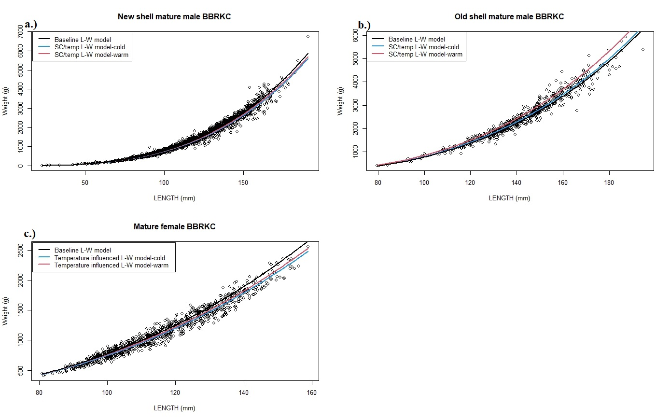

Figure 2. For male St. Matthew Island blue king crab; scatterplots of weights against carapace length measurements, comparing model fits for the baseline size-weight model, and the “best” maximum likelihood (ML) model incorporating shell condition and temperature effects, for the warmest and coldest year in the time series, , for a.) new shell males, b.) old shell males.

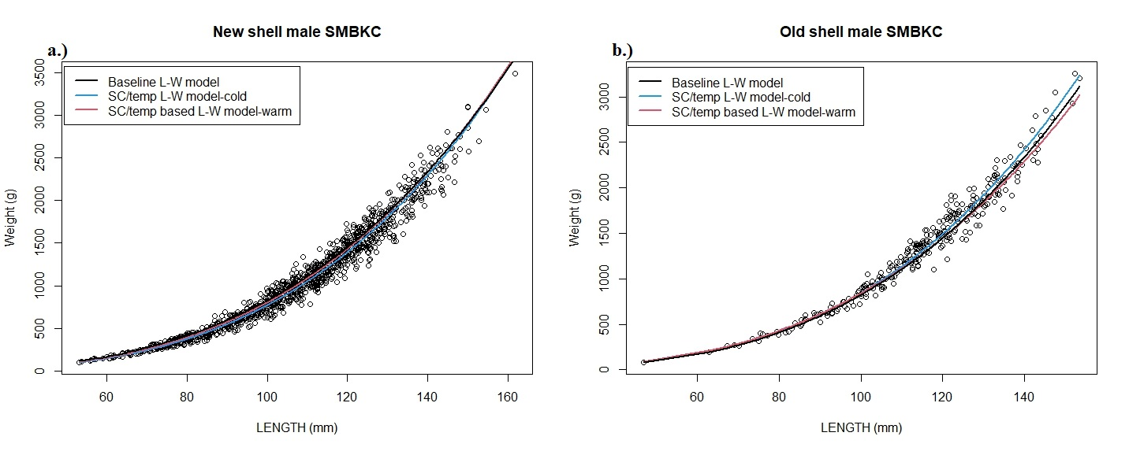

Figure 3. For male Eastern Bering Sea Tanner crab; scatterplots of weight against carapace width measurements comparing model fits for the baseline size weight model, and the “best” maximum likelihood (ML) model for incorporating shell condition, maturity and temperature, for the warmest and coldest year in the time series, for a.) new shell immature males, b.) old shell immature males, c.) new shell mature males, and d.) old shell mature males. Note similarity between all models for old shell immature and new shell mature males, and marked dissimilarity between the ML and baseline models for new shell immature and old shell mature males.

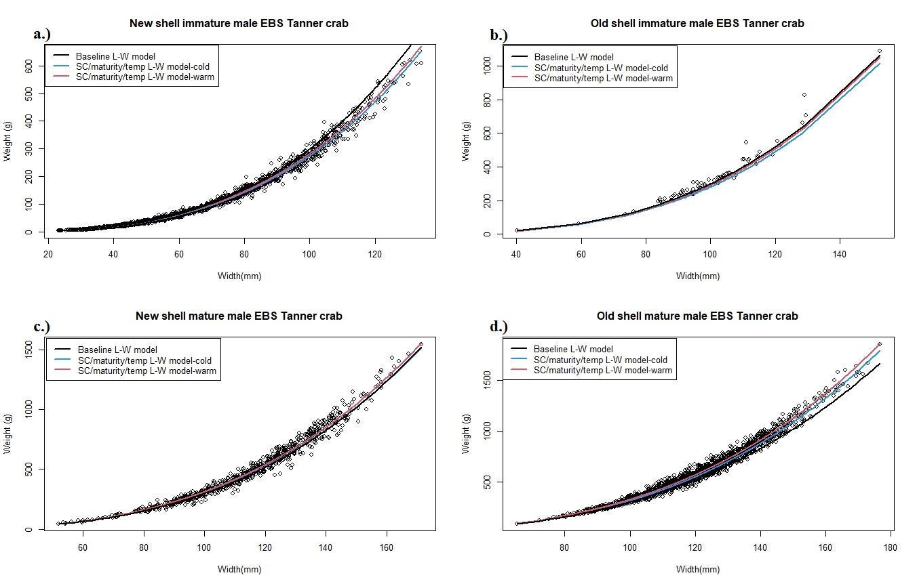

Figure 4. For male Eastern Bering Sea snow crab; scatterplots of weight against carapace width measurements comparing model fits for the baseline size weight model, and the “best” maximum likelihood (ML) model for incorporating shell condition, maturity and temperature, for the warmest and coldest year in the time series, for a.) new-shell immature males, b.) old-shell immature males, c.) new-shell mature males, and d.) old-shell mature males. Note high similarity for all models, except new shell immature males

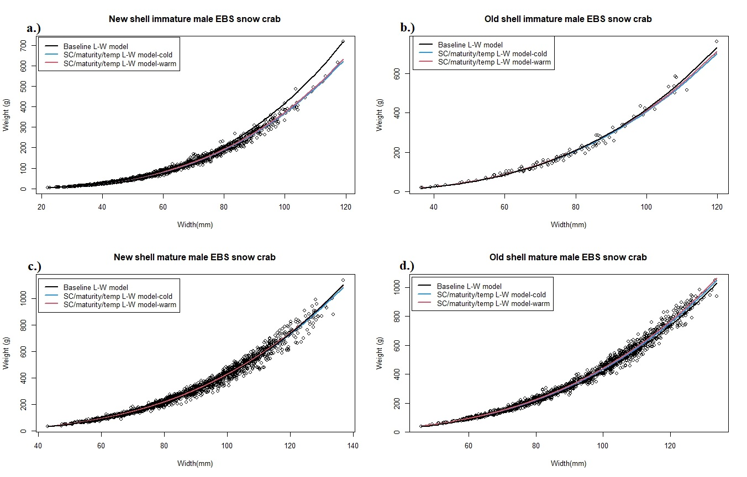

Figure 5. Percent difference in weight between shell condition-thermal effect maximum likelihood size-weight models by size for male a.) Bristol Bay red king crab, b.) St. Matthew blue king crab. For male red king crab, changes in difference across size range are of sufficiently small magnitude as to cause trend lines to appear flat.

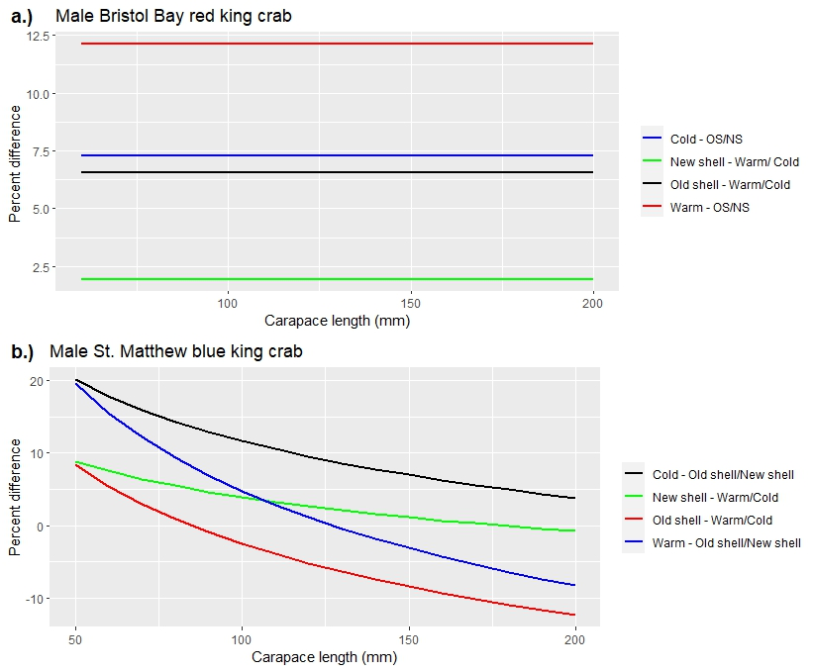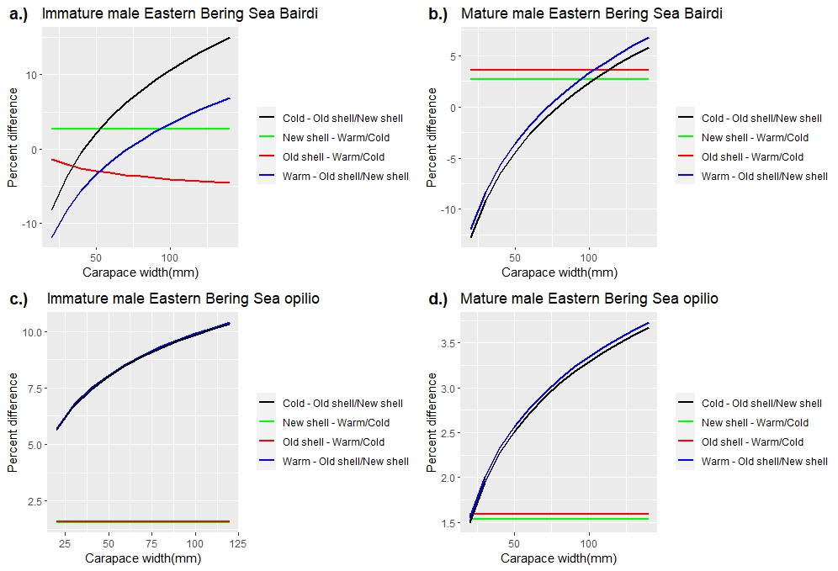

Figure 6. Percent difference in weight between shell condition-thermal effect maximum likelihood size-weight models by size for a.) Immature male eastern Bering Sea (EBS) Tanner crab, b.) Mature male eastern Bering Sea (EBS) Tanner crab, c.) Immature male eastern Bering Sea (EBS) snow crab, and d.) Mature male eastern Bering Sea (EBS) snow crab.

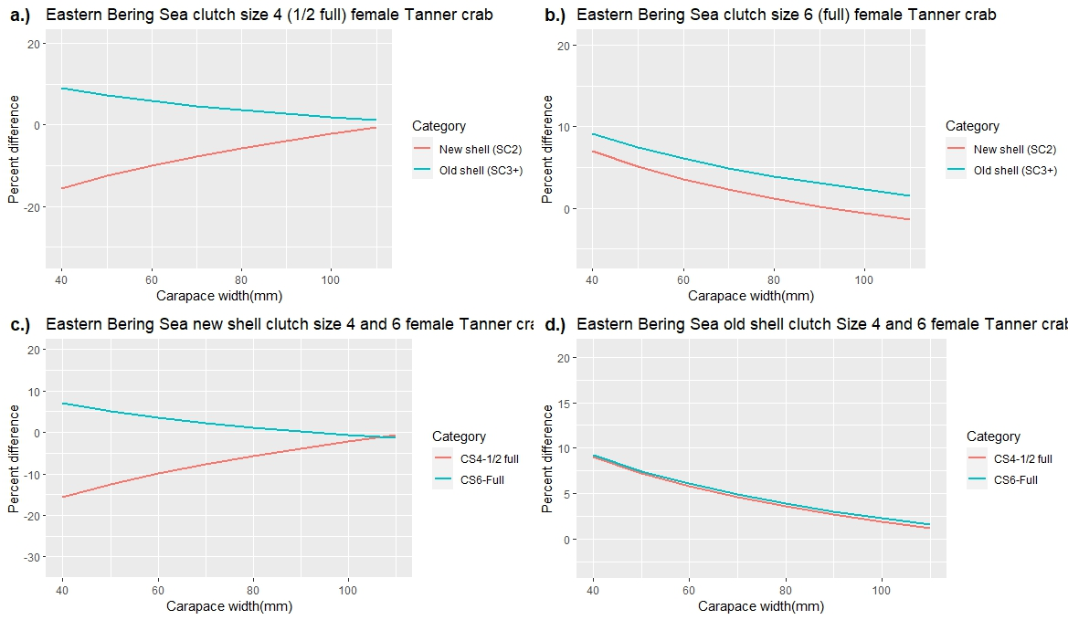

Figure 7. Percent difference in weight between female covariate-specific least-squares size-weight models and current standard models for female EBS Bairdi. Covariates are a.) Shell condition, b.) Temperature, c.) Clutch size = 4 (half full), d.) Clutch size = 6, e.) New shell + clutch size 4 and 6, f.) Old shell + clutch size 4 and 6.

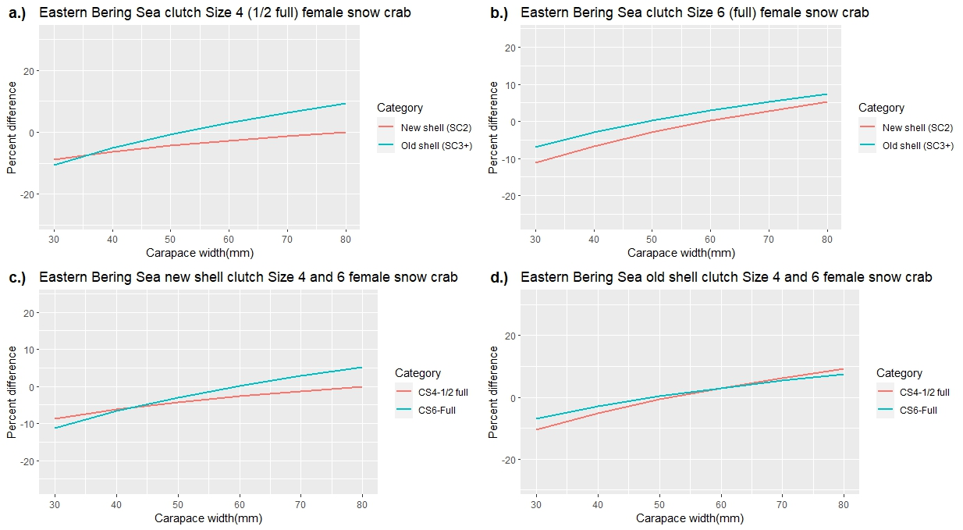

Figure 8. Percent difference in weight between female covariate-specific least-squares size-weight models and current standard models for female EBS opilio. Covariates are a.) Shell condition, b.) Temperature, c.) Clutch size = 4 (half full) and d.) Clutch size = 6, e.) New shell + clutch size 4 and 6, and f.) Old shell + clutch size 4 and 6.

Figure 9. Percent difference in weight at size between shell condition-only maximum likelihood (ML) size-weight models and current standard model, and between the ML null (no covariate effects) models for eastern Bering Sea (EBS) and northern Bering Sea (NBS) male a.) Norton Sound red king crab, b.) Northern Bering Sea blue king crab, and c.) Northern Bering Sea opilio crab.

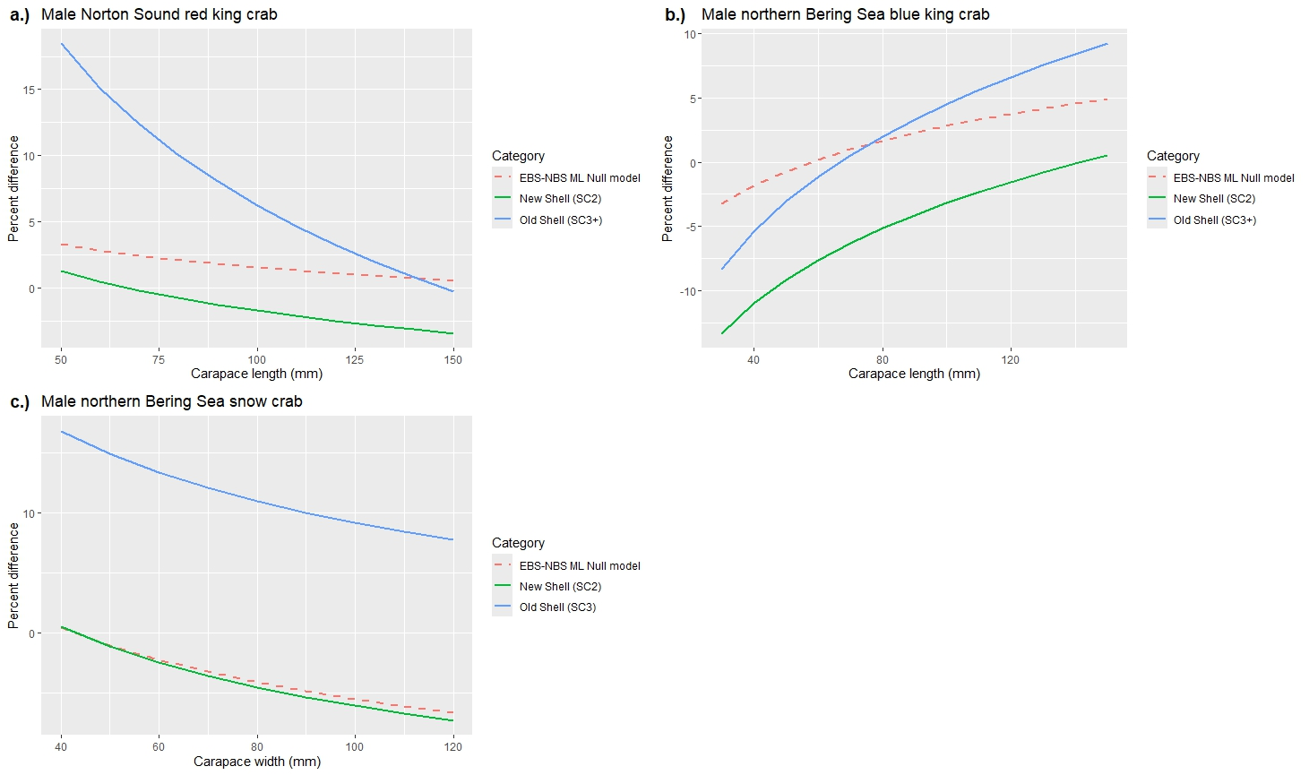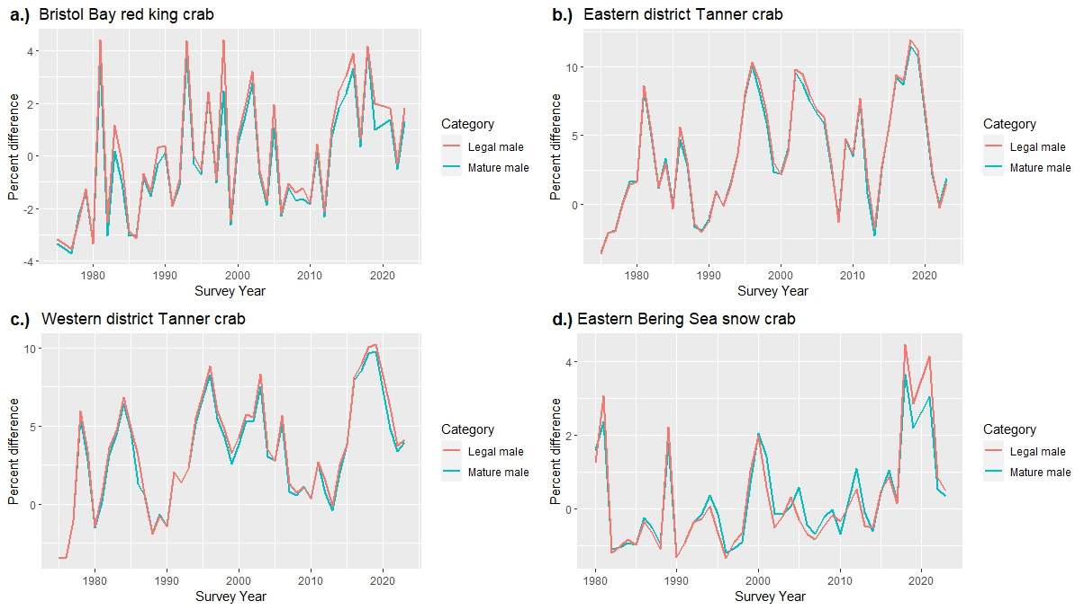

Figure 10. Percent difference in population biomass estimates for mature and legal to retain male size classes for; a.) Bristol Bay red king crab, b.) St. Matthew blue king crab, c.) Eastern district Tanner crab, d.) Western district Tanner crab and e.) Eastern Bering Sea opilio crab.